Data Mining
Semester Project
Project Name: Project Name
Project Team:
Project Team:
- Student Name 1انس صالح إبراهيم العطيوى (320230601061)

- Datasets
  - Use Kaggle website ( https://www.kaggle.com/datasets ) for selecting datasets
Table 1: All datasets
Dataset Name | Dataset Link | Field  (Domain) | No of Features | No of Instances (records) | Binary Class or Multi-class  (Mention them
Student Performance Prediction || EDA || ML | https://www.kaggle.com/code/ahmedabbas757/student-performance-prediction-eda-ml/input | Predicting students' success or failure | 6 | 10000 | Binary
Student Academic Performance Analysis 📚📈 | https://www.kaggle.com/code/bhartiprasad17/student-academic-performance-analysis/input | Predicting students' success or failure | 8 | 1000 | Binary
(Student Academic Performance Analysis 📚📈)
  - Visualization of Dataset
corr = df.corr()
plt.figure(figsize=(8,6))
sns.heatmap(corr, annot=True, cmap="coolwarm", fmt=".2f")
plt.title("Feature Correlation Heatmap") plt.show()
()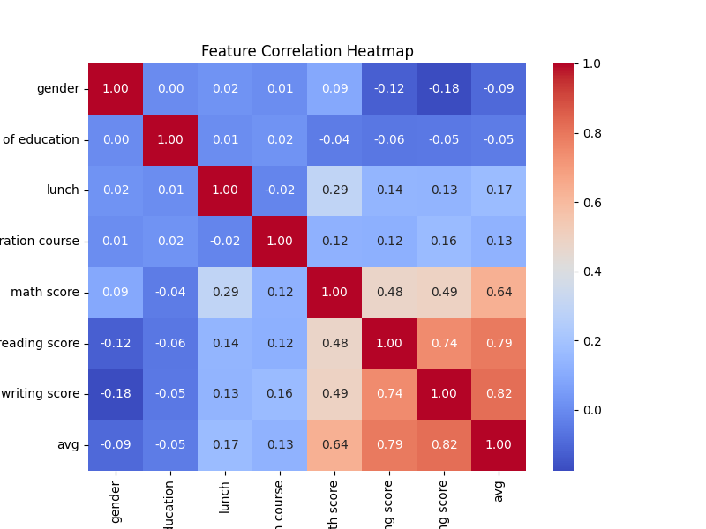

Insert a visualization that shows the classes’ distribution in the selected datasets.
plt.figure(figsize=(8, 4))
sns.countplot(x=y)
plt.title("avg (0 =Filed , 1 = Successful)")
plt.xlabel("avg")
plt.ylabel("Count")
plt.show()
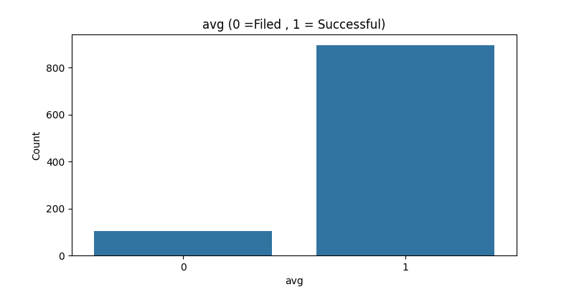

- The proposed model
  - Pre-processing step
(mention the pre-process techniques)

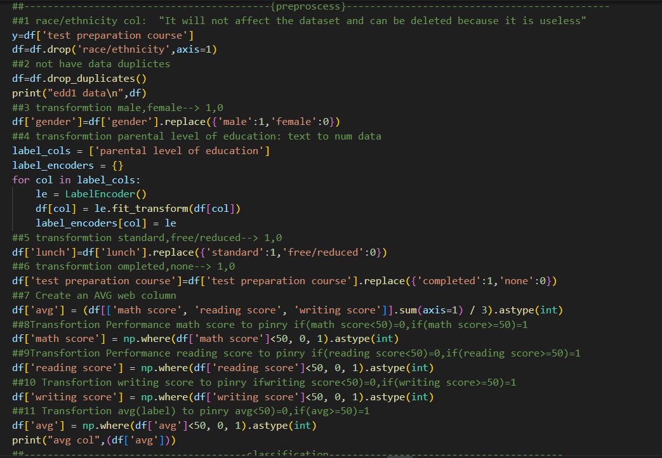
  - Classifiers (Machine learning algorithms)
(Describe briefly the selected classifiers)
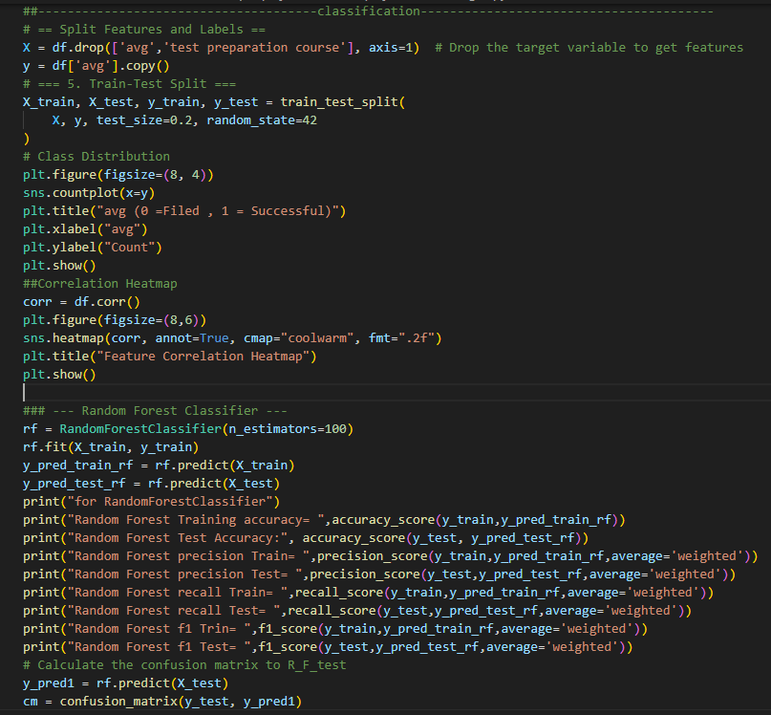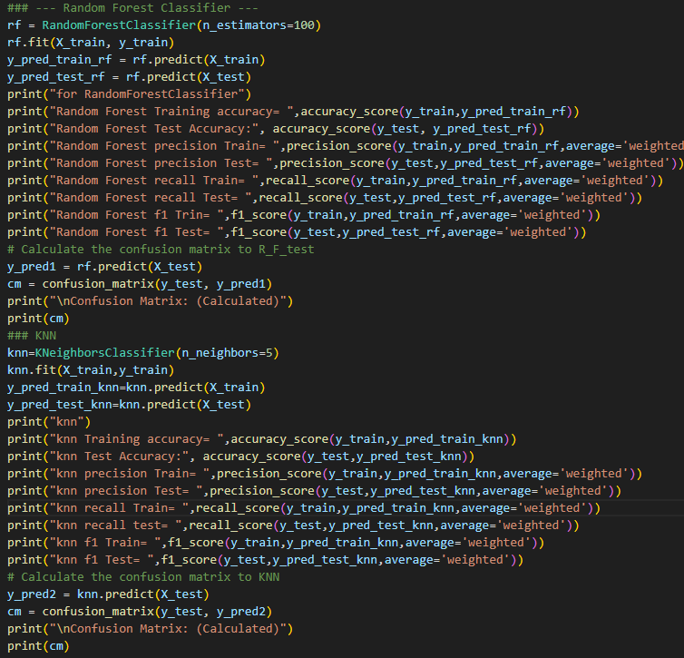
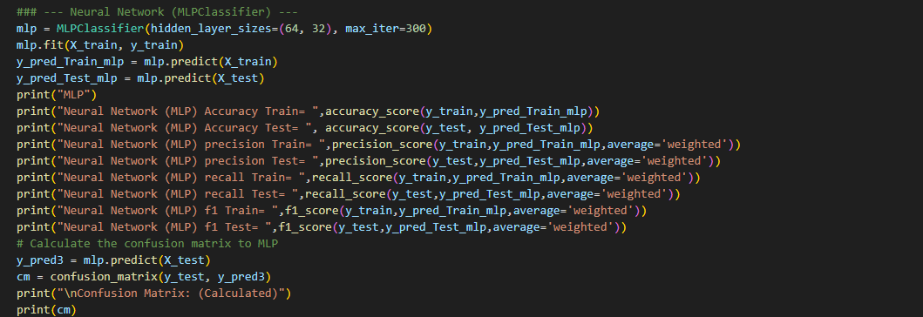
- Results and Discussion
  - Accuracy/ Precision/ Recall/ F1*Score/ Confusion Matrix/ROC for Model Training

Table: Results of Accuracy, Precision, Recall, and F1*Score for Model Training

Model (Random Forest/ Decision Tree/ SVM/ Naïve Byes/ Neural Networks/ KNN/ ..... | Accuracy | Precision | Recall | F1-Score
Model 1(R_ F) | 0.99125 | 0.991213412160204 | 0.99125 | 0.9911162455346901
Model 2(KNN) | 0.98125 | 0.9809304432815459 | 0.98125 | 0.9807178751241895
Model 3(MLP) | 0.99125 | 0.9911730511955682 | 0.99125 | 0.9911709582375496
….

Figure4: ROC for all models
Insert here

  - Accuracy/ Precision/ Recall/ F1*Score/ Confusion Matrix/ROC for Model Testing

Table: Results of Accuracy, Precision, Recall, and F1*Score for Model Testing

Model (Random Forest/ Decision Tree/ SVM/ Naïve Byes/ Neural Networks/ KNN/ ..... | Accuracy | Precision | Recall | F1-Score
Model 1(R_ F) | 0.97 | 0.9710055865921788 | 0.97 | 0.9683806818181817
Model 2(KNN) | 0.96 | 0.961767955801105 | 0.96 | 0.9569737165315648
Model 3(MLP) | 0.97 | 0.9710055865921788 | 0.97 | 0.9683806818181817
….

Figure1: Confusion Matrix of Model1 Testing(R_F)
Insert here
[[ 21 6]
[ 0 173]]
Figure2: Confusion Matrix of Model2 Testing (KNN)
Insert here
[[ 19 8]
[ 0 173]]
Figure3: Confusion Matrix of Model3 Testing(MLP)
Insert here
[[ 21 6]
[ 1 172]]
Figure4: ROC for all models
Insert here

  - Results Discussion
The results show that …….
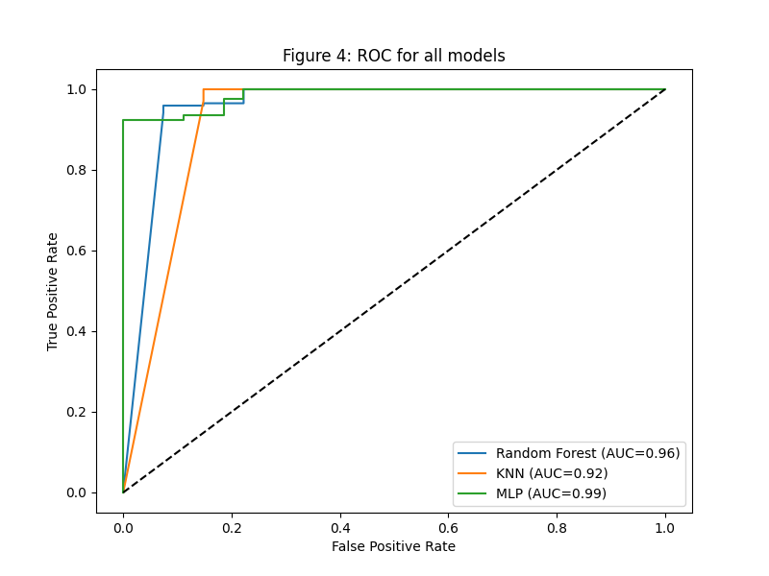

هذا النموذج يعتمد على النموذج السابق :
)Student Performance Prediction || EDA || ML(
يعتمد عليه من ناحية تقسيم (الفحص/التدريب)=(20/80) والتقنيات المستخدمة في النموذج السابق
1-MLP 2-KNN 3-R-F
وكان ذلك لتكون مقارنة عادلة بينهم اما عمليات التنظيف والتصحيح كانت للبيانات تختلف وكان العمل بترتيب.... عامود الأول كان ذكر/انثى اصبح 1/0 ثم العامود الثاني الذي يتحدث عن العرق/الأصل لم يكن ذو تأثير على بينات حذفته بشكل كامل العامود الثالث كان عن مستوى التعلمي للوالدين وكان يتكون من 6 درجات تقريبا وتم تحويلها الى بينات رقمية والعامود الرابع الغذاء قياسي/مجاني مخفض تم التحويل الى 1/0 والعامود الخامس دورة تحضير للاختبار مكتمل/لا 1/0 اما عامود السادس علامة الرياضيات والسابعة علامة القراء والعامود الثامن علامة الكتابة تم استخدامهم لوجد عامود جديد "المعدل وهوا ليبل كلاس" ثم تم تحويلهم كله الى راسب=0 ناجح=1 حسب فوق 50 ناجح تحت الخمسين راسب لتحويلها الى بيانات رقمية ثنائية

كانت الدقة جيدة وتتراوح بين (95_97)

- Python Code
- import pandas as pd
- import matplotlib.pyplot as plt
- import seaborn as sns
- import numpy as np
- from sklearn.preprocessing import LabelEncoder
- from sklearn.model_selection import train_test_split
- from sklearn.metrics import accuracy_score, precision_score, recall_score, f1_score, confusion_matrix, ConfusionMatrixDisplay,roc_curve, auc
- from sklearn.ensemble import RandomForestClassifier
- from sklearn.neighbors import KNeighborsClassifier

- from sklearn.svm import SVC
- from sklearn.tree import DecisionTreeClassifier
- from sklearn.neural_network import MLPClassifier
- from sklearn.ensemble import RandomForestClassifier

- # = Load Preprocessed CSV Data set1&& Data set2 =
- url=(r'C:\Users\Administrator\OneDrive\Desktop\dataset1.csv')
- df=pd.read_csv(url)
- print("data oraginal\n",df)
- ##------------------------------------------{preproscess}---------------------------------------------
- ##1 race/ethnicity col: "It will not affect the dataset and can be deleted because it is useless"
- y=df['test preparation course']
- df=df.drop('race/ethnicity',axis=1)
- ##2 not have data duplictes
- df=df.drop_duplicates()
- ##3 transformtion male,female--> 1,0
- df['gender']=df['gender'].replace({'male':1,'female':0})
- ##4 transformtion parental level of education: text to num data
- label_cols = ['parental level of education']
- label_encoders = {}
- for col in label_cols:
- le = LabelEncoder()
- df[col] = le.fit_transform(df[col])
- label_encoders[col] = le
- ##5 transformtion standard,free/reduced--> 1,0
- df['lunch']=df['lunch'].replace({'standard':1,'free/reduced':0})
- ##6 transformtion ompleted,none--> 1,0
- df['test preparation course']=df['test preparation course'].replace({'completed':1,'none':0})
- ##7 Create an AVG web column
- df['avg'] = (df[['math score', 'reading score', 'writing score']].sum(axis=1) / 3).astype(int)
- ##8Transfortion Performance math score to pinry if(math score<50)=0,if(math score>=50)=1
- df['math score'] = np.where(df['math score']<50, 0, 1).astype(int)
- ##9Transfortion Performance reading score to pinry if(reading score<50)=0,if(reading score>=50)=1
- df['reading score'] = np.where(df['reading score']<50, 0, 1).astype(int)
- ##10 Transfortion writing score to pinry ifwriting score<50)=0,if(writing score>=50)=1
- df['writing score'] = np.where(df['writing score']<50, 0, 1).astype(int)
- ##11 Transfortion avg(label) to pinry avg<50)=0,if(avg>=50)=1
- df['avg'] = np.where(df['avg']<50, 0, 1).astype(int)
- print("edd1 data\n",df)

- ##--------------------------------------classification----------------------------------------
- # == Split Features and Labels ==
- X = df.drop(['avg','test preparation course'], axis=1) # Drop the target variable to get features
- y = df['avg'].copy()
- # === 5. Train-Test Split ===
- X_train, X_test, y_train, y_test = train_test_split(
- X, y, test_size=0.2, random_state=42
- )
- # Class Distribution
- plt.figure(figsize=(8, 4))
- sns.countplot(x=y)
- plt.title("avg (0 =Filed , 1 = Successful)")
- plt.xlabel("avg")
- plt.ylabel("Count")
- plt.show()
- ##Correlation Heatmap
- corr = df.corr()
- plt.figure(figsize=(8,6))
- sns.heatmap(corr, annot=True, cmap="coolwarm", fmt=".2f")
- plt.title("Feature Correlation Heatmap")
- plt.show()

- ### --- Random Forest Classifier ---
- rf = RandomForestClassifier(n_estimators=100)
- rf.fit(X_train, y_train)
- y_pred_train_rf = rf.predict(X_train)
- y_pred_test_rf = rf.predict(X_test)
- print("for RandomForestClassifier")
- print("Random Forest Training accuracy= ",accuracy_score(y_train,y_pred_train_rf))
- print("Random Forest Test Accuracy:", accuracy_score(y_test, y_pred_test_rf))
- print("Random Forest precision Train= ",precision_score(y_train,y_pred_train_rf,average='weighted'))
- print("Random Forest precision Test= ",precision_score(y_test,y_pred_test_rf,average='weighted'))
- print("Random Forest recall Train= ",recall_score(y_train,y_pred_train_rf,average='weighted'))
- print("Random Forest recall Test= ",recall_score(y_test,y_pred_test_rf,average='weighted'))
- print("Random Forest f1 Trin= ",f1_score(y_train,y_pred_train_rf,average='weighted'))
- print("Random Forest f1 Test= ",f1_score(y_test,y_pred_test_rf,average='weighted'))
- # Calculate the confusion matrix to R_F_test
- y_pred1 = rf.predict(X_test)
- cm = confusion_matrix(y_test, y_pred1)
- print("\nConfusion Matrix: (Calculated)")
- print(cm)
- ### KNN
- knn=KNeighborsClassifier(n_neighbors=5)
- knn.fit(X_train,y_train)
- y_pred_train_knn=knn.predict(X_train)
- y_pred_test_knn=knn.predict(X_test)
- print("knn")
- print("knn Training accuracy= ",accuracy_score(y_train,y_pred_train_knn))
- print("knn Test Accuracy:", accuracy_score(y_test,y_pred_test_knn))
- print("knn precision Train= ",precision_score(y_train,y_pred_train_knn,average='weighted'))
- print("knn precision Test= ",precision_score(y_test,y_pred_test_knn,average='weighted'))
- print("knn recall Train= ",recall_score(y_train,y_pred_train_knn,average='weighted'))
- print("knn recall test= ",recall_score(y_test,y_pred_test_knn,average='weighted'))
- print("knn f1 Train= ",f1_score(y_train,y_pred_train_knn,average='weighted'))
- print("knn f1 Test= ",f1_score(y_test,y_pred_test_knn,average='weighted'))
- # Calculate the confusion matrix to KNN
- y_pred2 = knn.predict(X_test)
- cm = confusion_matrix(y_test, y_pred2)
- print("\nConfusion Matrix: (Calculated)")
- print(cm)

- ### --- Neural Network (MLPClassifier) ---
- mlp = MLPClassifier(hidden_layer_sizes=(64, 32), max_iter=300)
- mlp.fit(X_train, y_train)
- y_pred_Train_mlp = mlp.predict(X_train)
- y_pred_Test_mlp = mlp.predict(X_test)
- print("MLP")
- print("Neural Network (MLP) Accuracy Train= ",accuracy_score(y_train,y_pred_Train_mlp))
- print("Neural Network (MLP) Accuracy Test= ", accuracy_score(y_test, y_pred_Test_mlp))
- print("Neural Network (MLP) precision Train= ",precision_score(y_train,y_pred_Train_mlp,average='weighted'))
- print("Neural Network (MLP) precision Test= ",precision_score(y_test,y_pred_Test_mlp,average='weighted'))
- print("Neural Network (MLP) recall Train= ",recall_score(y_train,y_pred_Train_mlp,average='weighted'))
- print("Neural Network (MLP) recall Test= ",recall_score(y_test,y_pred_Test_mlp,average='weighted'))
- print("Neural Network (MLP) f1 Train= ",f1_score(y_train,y_pred_Train_mlp,average='weighted'))
- print("Neural Network (MLP) f1 Test= ",f1_score(y_test,y_pred_Test_mlp,average='weighted'))
- # Calculate the confusion matrix to MLP
- y_pred3 = mlp.predict(X_test)
- cm = confusion_matrix(y_test, y_pred3)
- print("\nConfusion Matrix: (Calculated)")
- print(cm)

- plt.figure(figsize=(8,6))

- # Random Forest
- y_prob_rf = rf.predict_proba(X_test)[:,1]
- fpr, tpr, _ = roc_curve(y_test, y_prob_rf)
- plt.plot(fpr, tpr, label=f"Random Forest (AUC={auc(fpr,tpr):.2f})")

- # KNN
- y_prob_knn = knn.predict_proba(X_test)[:,1]
- fpr, tpr, _ = roc_curve(y_test, y_prob_knn)
- plt.plot(fpr, tpr, label=f"KNN (AUC={auc(fpr,tpr):.2f})")

- # MLP
- y_prob_mlp = mlp.predict_proba(X_test)[:,1]
- fpr, tpr, _ = roc_curve(y_test, y_prob_mlp)
- plt.plot(fpr, tpr, label=f"MLP (AUC={auc(fpr,tpr):.2f})")

- # قاعدخ
- plt.plot([0,1], [0,1], 'k--')

- plt.title("Figure 4: ROC for all models")
- plt.xlabel("False Positive Rate")
- plt.ylabel("True Positive Rate")
- plt.legend()
- plt.show()

